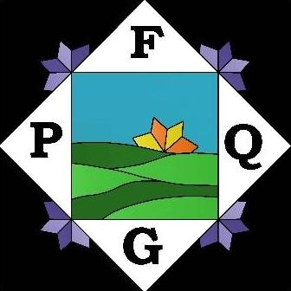

Foothills Piecemakers Quilting Guild Newsletter

Greenville, SC

foothillsquilts.com

March
202
6

Vol 3
6
, No
0
8

President’s Message 

March already!! Our “Quilting Greenville Style” quilt show date is fast approaching!
Be sure to get those registrations in. At our March meeting, you will have the opportunity to sign up for volunteer opportunities. Thank you for all the hard work that has gone into this show preparation. Gold stars to Jana Fetch for her wonderful planning and organizing skills to make this show successful.
Since we did not meet in February due to the weather, the meeting in March will be even sweeter. Please be finishing up your challenge quilt entries for the March meeting.
Thank you to the 7 people for our nominating committee. The members of the committee are the following: Karen Baird, Gloria Bobier, Wanda Caldwell, Melanie
DeMoise, Karen Kelly, Mary Jill Kroske, and Barbara Thrush. You might be receiving a phone call asking you to consider serving as an elected officer. We would love to have people volunteer to fill an office. Participation as an officer or committee chair helps make your guild experience
See you on Tuesday evening, March 3rd. Activities that evening begin at 5:00 to help with philanthropy projects if you can, 6:15 for fellowship and 6:45 for the meeting. See you there! Nancy Jones Refreshments and Birthdays
Ruth Bartholomew 5- Mar
Melanie DeMoise 5-Mar
Dawn Holter 7- Mar
Patricia Bush 9-Mar
Sandy Wolf 17- Mar
Marilyn Donnel 26 -Mar
Karen McGraw 26-Mar
Ruth Rembis 29- Mar
Sheryl Sane 29- Mar

Happy Birthday, Ladies!
- Mary J Kroske

Resource Center
No book reviews this month.
even more meaningful. Thank you.
1

- Ruth Bartholomew
FPQG Officer/Chair Positions 2025-2026:

Here are the current officers and committee chairs for our year ending in June. The symbols *** means the position is available.

Elected Officers:
President Nancy Jones
Vice-President Merry-Beth Noble
Treasurer Linda Ligon
Recording Secretary Mellisa Gravitt
Corresponding Secretary Carol Johnson
Newsletter Editor Darlene Morse
Web Master Diane Kent

Committee Chairs:
Resource Center Ruth Bartholomew
Hospitality (Dollar Door Prize, Name Tag) Quilting Greenville Style at the
Greenville Shriners Center. April 24 and 25, 2026 – deadline is March 3 for quilt submission. Give to Ruth Bartholomew or Darlene Morse at the meeting, or mail before March 3. Currently have 12 vendors under contract. Each member who volunteers at least 3 hours will get free admission to the show. Need helpers to hang quilts and to man areas in the show. Keep your eyes open for bulletin boards to post up our announcement of our show.

Sylvia Hurst Volunteer slots will continue to be added in
Quilt Show Jana Fetch the upcoming weeks.
Membership Candy Friday &
Sheila Barhorst Show & Share



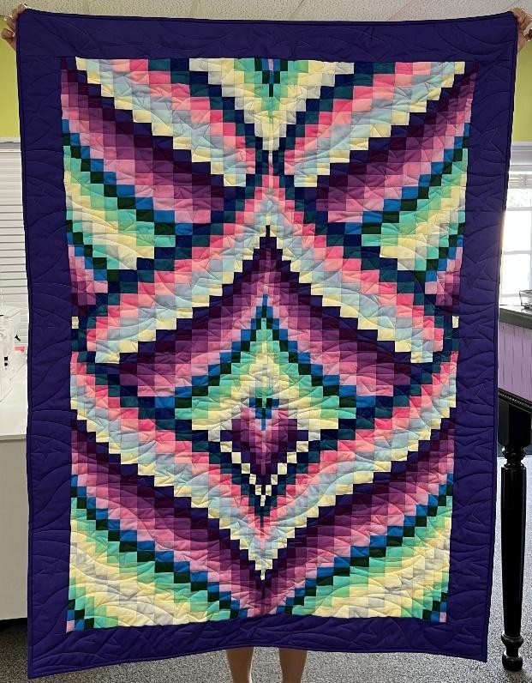
Hostess ***

Darlene Mo
rse made the
baby bargello
quilt
above
in
Feb.
using h
er hand
-
dyed fabrics
;
there were 16
62
seams to match
!

Opportunity Quilt Suzanne Brehm
Challenge Quilt Jennifer Neubauer
Guild Sales Linda Harper & Barbara Thrush
Philanthropy Paula Bryan
Publicity ***
Refreshments Terry Weinbender
& MJ Kroske
Storage Superintendent Debbie Gantt

Meeting Minutes Important info from our
January meeting minutes:

Jennifer Neubauer – Challenge quilt is due at the March meeting. You have plenty of time. Tools, notions and trims. Quilt something you want to display in your studio. No side smaller than 12 inches and no side larger than 36 inches. Make something that you would really like to hang in your home or next to your machine.
Jana Fetch with the Quilt Show:
Please volunteer to help with the quilt show. We will be introducing Sign Up Genius at the March meeting. If you want to get a jumpstart, follow this link: https://www.signupgenius.com/go/20F 0C4CA9A62AA1FF2-62404320-quilt

Programs

March – Jennifer Neubauer – Quilt
Challenge
April - Quilt Show - TBD
May - Lynn Christiansen - Travel Quilts and
Postcard Quilt Class
June - Camille Levi - Unique Quilt Design and Memory Quilts
Do you have an idea or connection for one our programs? Let me know! Feel free to contact me any time! Merry-Beth Noble, VP Programs merrybethnoble@gmail.com
864-510-8066

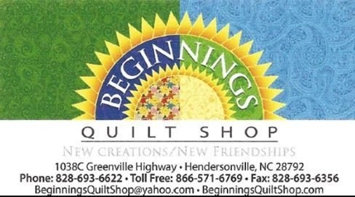





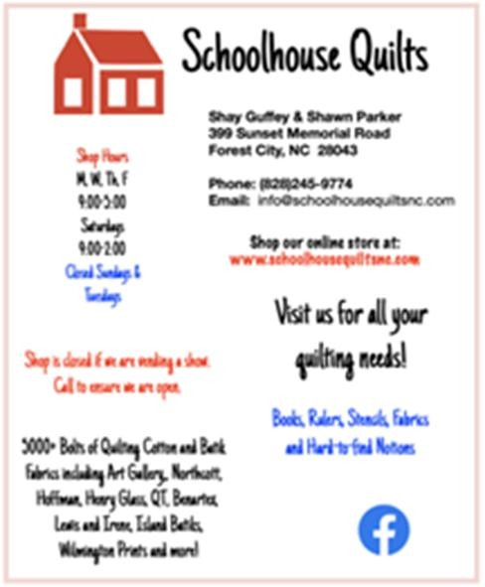

April 2026 FPQG Quilt Show

Quilting Greenville Style: 2026 Quilt Show Update:
It’s almost time to show the community what we’ve been working on! As we gear up for our 2026 show, Quilting Greenville Style, we’re looking for volunteers and— most importantly—your beautiful quilts. Be sure to get them registered by the March 3 meeting.
Check your email shortly for all the ways you can pitch in and help with the show. In the meantime, grab some postcards and posters at the next meeting to share with your favorite local spots. Help us paint the town by sharing them with your favorite shops, cafes, and friends! - Jana Fetch

Notes from Philanthropy
‘Baskets’ are still in need of fabrics and sundries, so please continue to bring your donations for baskets this month! Thank you so much for your support…Y’all ARE the philanthropists!

The Pillowcase Project
Big and little ways you can help (now and throughout the year):
—You can turn in completed pillowcases at Philanthropy table. Remember to sign them in!
—You can make pillowcases from your own stash.
—You can make pillowcase kits from your stash for others to sew.
—You can sign out pillowcase kits from the Philanthropy table.
—You can donate pillowcase ‘parts’ (if you have in your stash the following size fabrics, but they really don’t go with each other):
27” or 28” x width of fabric, cut square at each end.
8” or 9” or 10” x width of fabric, cut square at each end.
2” x width of fabric, or (full-length) orphan jellyroll strips.
There are numerous instructional videos on the internet for Burrito Pillowcases. The cutting lengths may vary slightly from one video to another. That’s okay! Choose one that works for you. It just needs to fit a standard pillow.
We have come to the conclusion that our guild alone is not capable of providing pillowcases for the LilyPads statewide, not even when working on this project year- round. We are talking many hundreds every year! The Philanthropy committee cannot possibly cut out 400+ kits a year. And with each pillowcase using a yard of fabric at conservatively $10 a yard, well, do the math! You all are SO generous with your time and materials…this is NOT a guilt trip!
So (after the holidays), we will be looking into communicating with and/or through QSC to involve other guilds in providing for their own local areas. (One guild in each district would be great!)
Blessings to you all! Paula, Debbie, Gayl and Johellen



Membership
We have no new membership news for this month.
– Sheila Barhorst

Dollar Door Prize
We're going to give you a choice for the Dollar Door Prize again this month. The winner may choose between a physical door prize or 50/50 (50% of the money taken in). And the more of you that
participate, the bigger the prize. So, BRING YOUR DOLLARS! - Sylvia Hurst
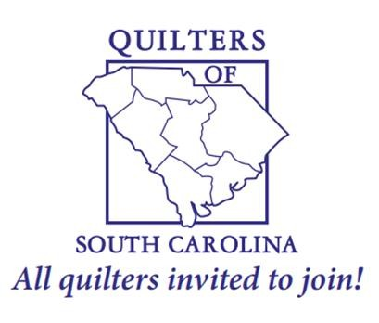

Upcoming Events
Cobblestone Quilt Guild in Charleston, SC quilt show, March 20-21, 2026 & maybe the 22nd at Trident Technical College in North Charleston. They want to know if anyone is interested in a bus trip to their show.
FPQG Spring Retreat, Monday, Mar. 16 – Thursday, Mar. 19, 2026. Contact Pam Kowalk. See details in this newsletter.
Quilt Festival, March 20–22, 2026 sponsored by Palmetto Quilt Guild of Hilton Head.

Quilting Retreat News
Our spring quilting retreat is fast approaching. The dates are Monday, March 16 at 8am through Thursday, March 19 at 1pm. It will take place in Denton, NC at The Salvation Army Camp Walter Johnson. A huge sewing room with a gorgeous view is available to us and the lodge accommodations are comfortable. It is a beautiful campsite!! I hope you will consider joining us. It is really a great time to get to know other members as we eat and sew together. Plus, it is a great environment to get advice/help if needed. (It will be a perfect time to finish a project that can be placed in our quilt show). Also, keep in mind that since we paid the deposit in 2025, we are getting a lower price this spring than the price will be next time in the fall-- due to a price increase.

If you are interested in attending this event I need to get your name on the list. So far, I have 18 names of those who are planning to come.
Here’s the breakdown… We will begin with supper on Monday night and end with the morning meal on Thursday. On Tuesday and Wednesday, we will enjoy 2 meals. Breakfast is $10, brunch is $12, and supper is $14. Please keep in mind that they now have a big refrigerator in the sewing room (for lunch supplies or snacks) that is for our use.

Single room ($222) plus meals for a total of $294.
Double room ($111) plus meals for a total of $183 or $189.
Full payment is to be given to Pam on or before the March 3rd meeting.

- Pam Kowalk

Next Guild Meeting
Tuesday, March 3, 2025
E. Lee Rd Methodist Church in Taylors (1377 E. Lee Rd.) Philanthropy: 5:00 p.m. Show Planning No mtg in March Social time: 6:15 p.m.
Business: 6:45 p.m.
Program: 7:10 p.m.

Newsletter Submissions Please submit information for the next newsletter by March 20 (the day after the retreat) to Darlene Morse at scfabricdyer@gmail.com.

Don’t forget: Show and Share, Refreshments, Philanthropy items to turn in, Nametag, $1 for the door prize, guild sales, quilt show donations & registration forms with photos attached.

